NAME:B.Pavani

MBL :7569217017

E-MAIL:bingipavani3432gmail.com

PEERING ASSIGNMENT

* Create a VPC in Sydney region naming Sydney-vpc and attach subnet,internet gateway and route table

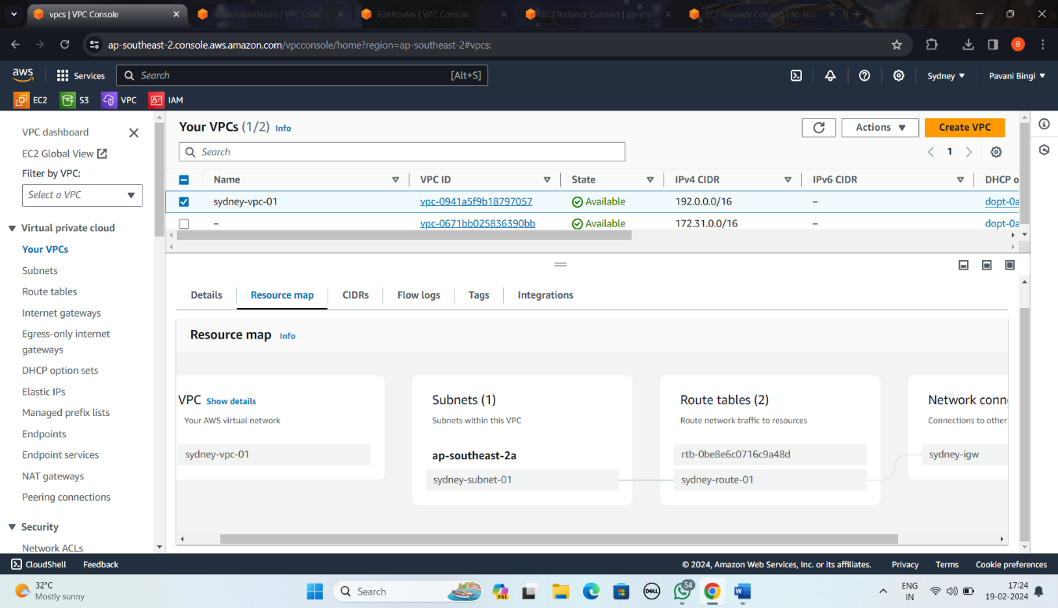

* Create Ec2 instance in the same region by name Sydney-ec2

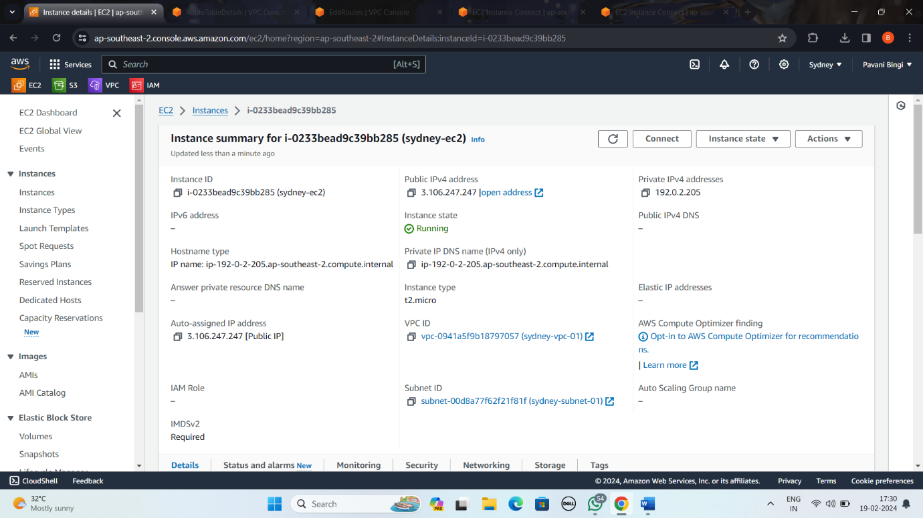

* enter into security groups edit inbound rules >>http and source save the changes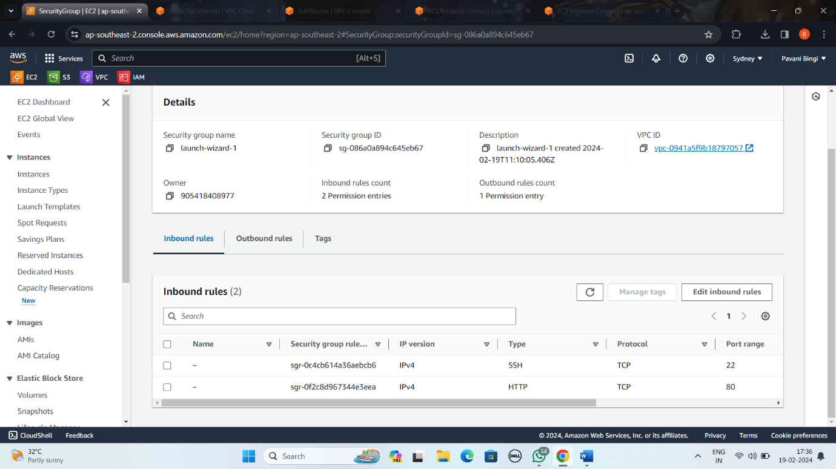
* connect to the CLI of the instance and connect to the root user,update the application packages.Install nginx for checking peering connection between vpc.use the command cd to change directory to default address of nginx and use ls to list all files and directory then remove the index.html file.create new file with name index.html by adding the wanted data . check weather the server is active or dead by using the basic commands

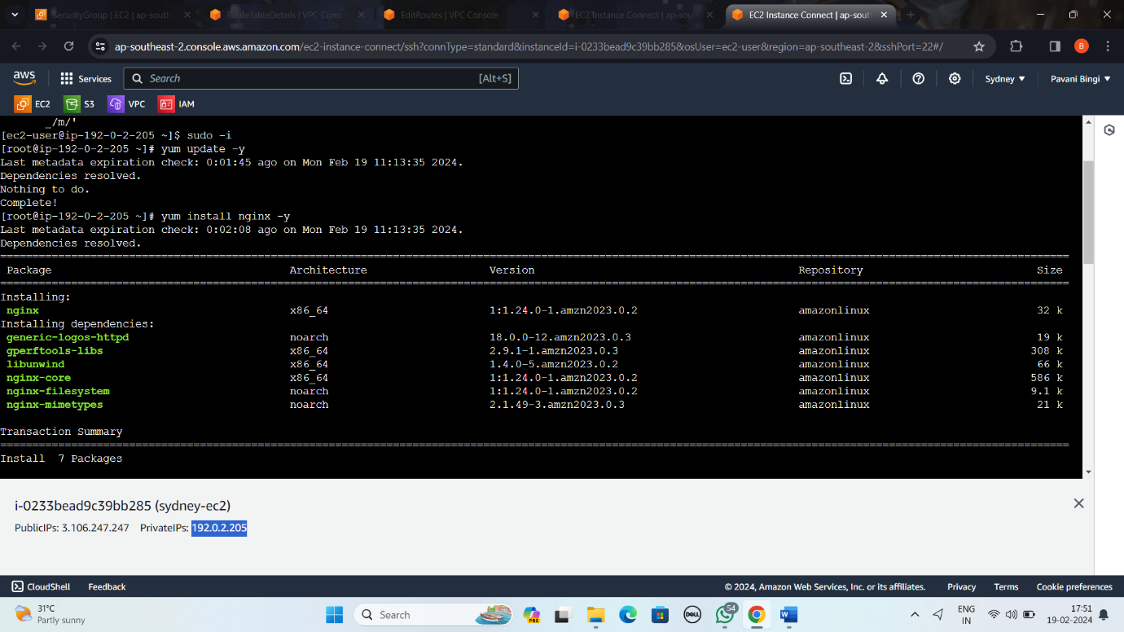

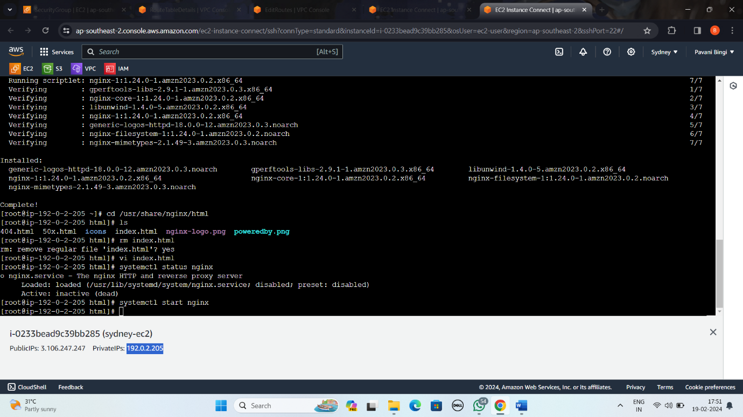

* if the server is active copy the public address and paste it and add default port number of nginx which is 80 using colon : after the public ip

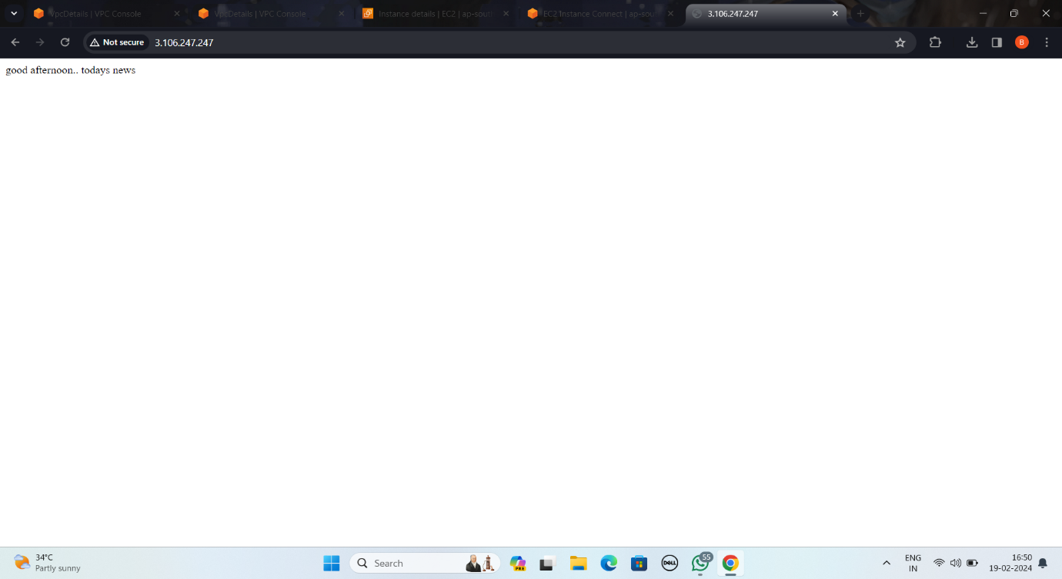

* create a new vpc in another region attach subnet,internet gateway and routetable

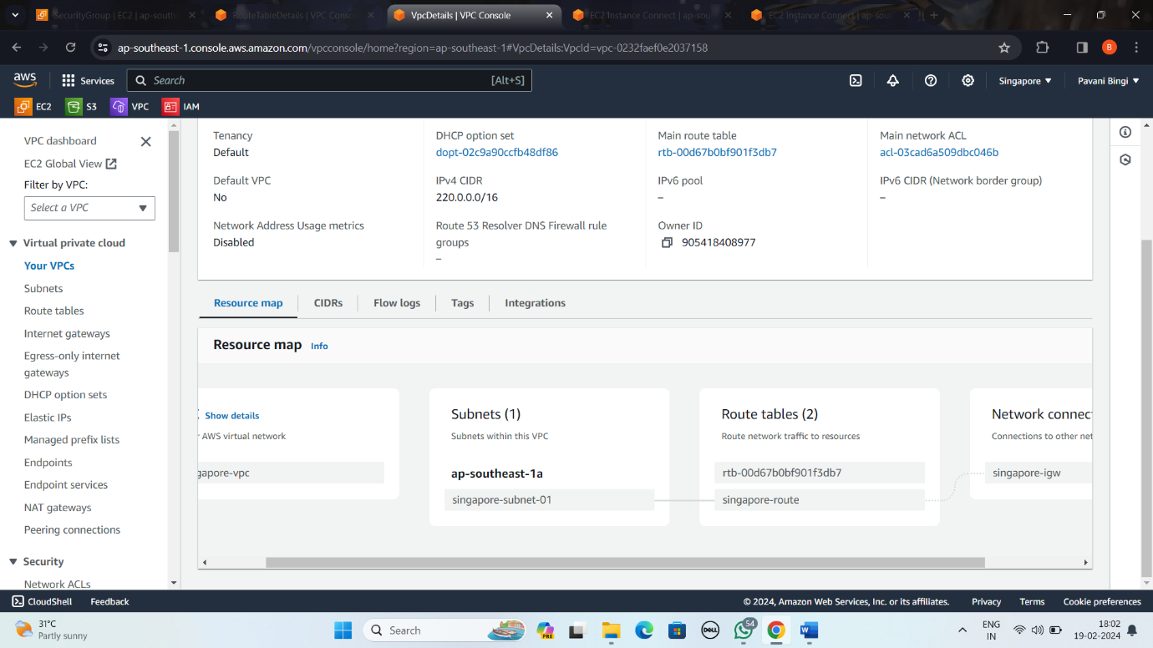

* enter into peering connections and new peering connection for two vpc’s in diff regions by passing vpc id

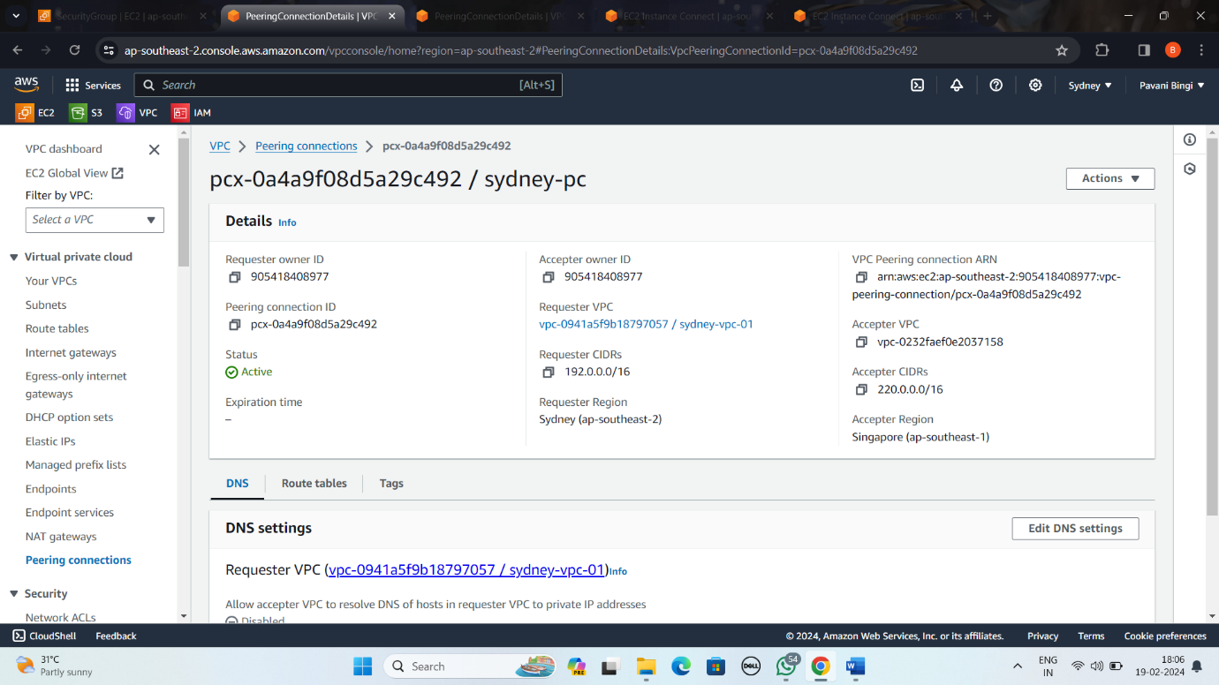

* accept the peering connection in another region for connection establishment and then goto routetable give destination address to allow the traffic to flow in the both vpc

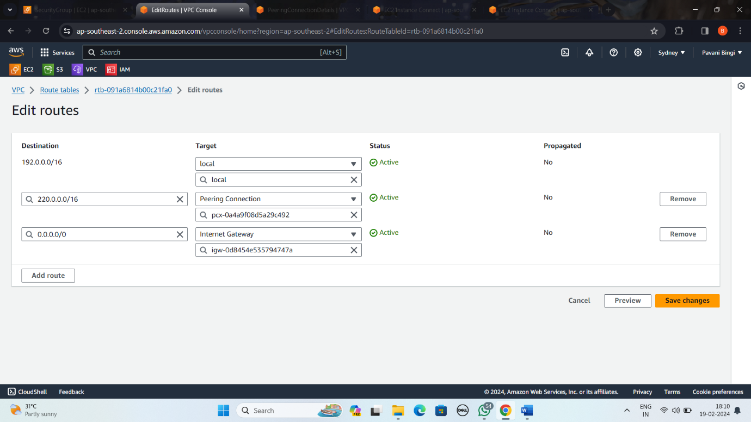

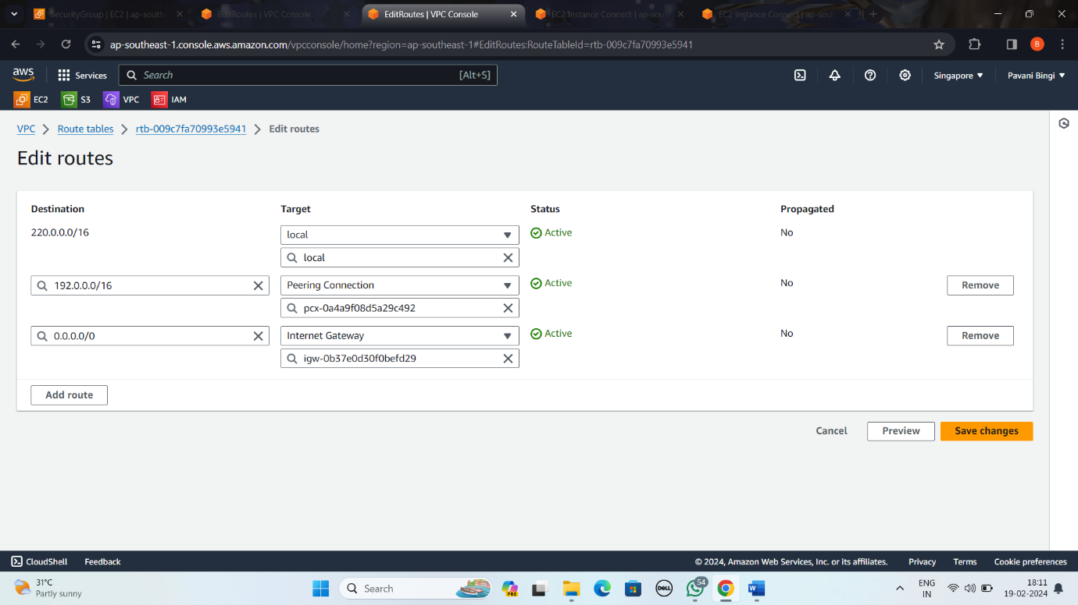

* after connecting to two vpc’s in two diff regions by using peering goto the instance in the new region and create a new instance with following vpc settings

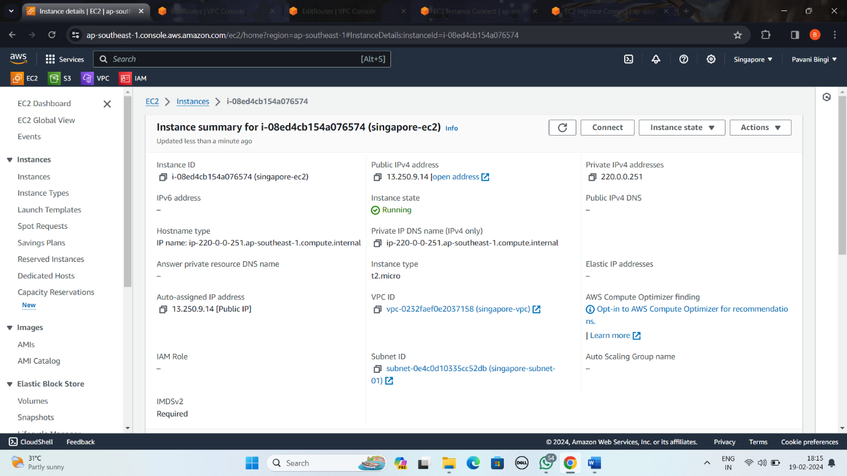

* now connect to CLI and connect to the root user for checking the peering connection establishment in the new instance which is on a different region

